## S.D.M.E Society’s

**SDM COLLEGE OF ENGINEERING AND TECHNOLOGY DHAVALAGIRI, DHARWAD-580002**



(AFFILIATED TO VISHVESVARAYS TECHNOLOGICAL UNIVERSITY)

**DEPARTMENT OF INFORMATION SCIENCE & ENGINEERING**

**Design Phase On**

**FACIAL EMOTION BASED MUSIC RECOMMENDATION SYSTEM**

Under the guidance of Dr.Vandana S Bhat

SUBMITTED BY

**DHANYA M 2SD18IS017**

**KAVYA HIREGOUDAR 2SD18IS023**

**NANDITA HIREMATH 2SD18IS075**

**SHREENIDHI JOSHI 2SD18IS047**

8th semester B.E Academic Year 2021-22

**LIST OF CONTENTS**

|  |  |  |
| --- | --- | --- |
| **SL No.** | **Name** | **Page No** |
| 1 | ER Diagram | 4 |
| 2 | Data Flow Diagram | 5 |
| 3 | Architectural Diagram | 6 |
| 4 | Client Server Model | 7 |
| 5 | UML Design | 8 |
| 5.1 | Class Design | 9 |
| 5.2 | Advanced State Design | 9 |
| 5.3 | Advanced Interaction Model | 10 |
| 5.3.1 | Use Case Model | 10 |
| 5.3.2 | Sequence Model | 12 |
| 6 | Swimlane Activity Model | 13 |
| 7 | User Interface Design | 14 |

# LIST OF FIGURES

|  |  |  |
| --- | --- | --- |
| SL No. | **Name** | **Page No.** |
| 1 | ER Diagram | **4** |
| 2 | Data Flow Diagram | **5** |
| 3 | Architectural Diagram | **6** |
| 4 | Client Server Model | **7** |
| 5.1.1 | Class Diagram | **8** |
| 5.1.2 | Advanced Class Design | **09** |
| 5.1.3 | Advanced State Design | **09** |
| 5.2.1 | Use Case Model | **10** |
| 5.2.2 | Sequence Model | **12** |
| 6 | Swimlane Activity Model | **13** |
| 7 | User Design Interface | **14** |

## ER DIAGRAM

**ER Diagram** stands for Entity Relationship Diagram, also known as ERD is a diagram that displays the relationship of entity sets stored in a database. In other words, ER diagrams help to explain the logical structure of databases. ER diagrams are created based on three basic concepts: entities, attributes and relationships.ER Diagrams contain different symbols that use rectangles to represent entities, ovals to define attributes and diamond shapes to represent relationships.

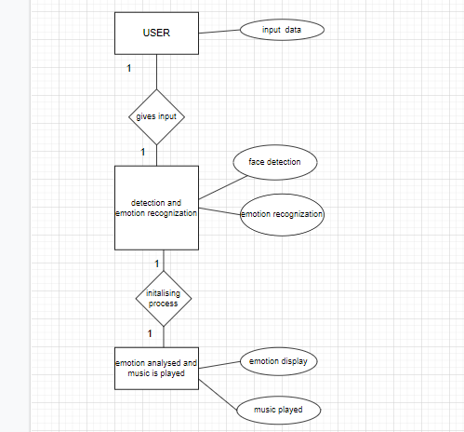

Fig 1. ER Diagram of FEB music recommendation system

## DATA FLOW DIAGRAM

**Data Flow Diagrams** are used to graphically represent the flow of data in a business information system. DFD describes the processes that are involved in a system to transfer data from the input to the file storage and reports generation. Data flow diagrams can be divided into logical and physical. The logical data flow diagram describes flow of data through a system to perform certain functionality of a business. The physical data flow diagram describes the implementation of the logical data flow.

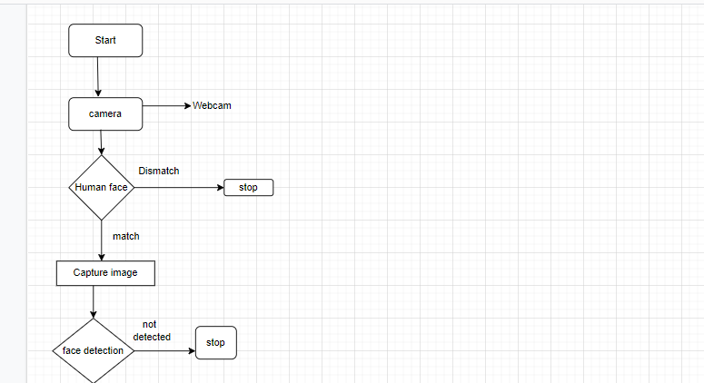

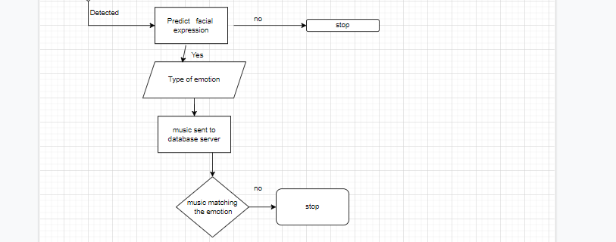

Fig 2. Data Flow Diagram of FEB music recommendation system

The above data flow diagram from Fig. 2. Shows the flow of data for recognizing the emotion and based on that playing the song model.

Step1. The image is inputted to the webcam.

Step 2. The emotion of the user is being recognized by capturing the facial expression using OpenCV by identifying the Haar features.

Step 3. Feature Extraction will take place using VGG16

Step 4. The emotions are then classified into 7 different classes of emotions using a Convolution Neural Network.

Step 5. In this step the emotion is being sent to server and matched with Kaggle dataset.

Step 6. The recognized expression is stored in database and the song which is related to that emotion is played from the music model.

## ARCHITECTURAL DESIGN

Architectural design is a process for identifying the sub-systems making up a system and the framework for sub-system control and communication. The output of this design process is a description of the software architecture. Architectural design is an early stage of the system design process. It represents the link between specification and design processes and is often carried out in parallel with some specification activities. It involves identifying major system components and their communications.

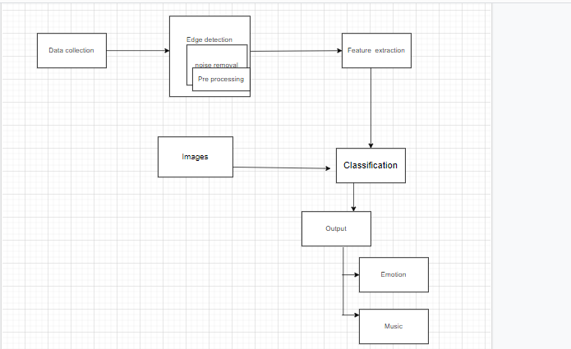

Fig 3. Architectural Designm of FEB music recommendation system

The architectural design for emotion-based music recommendation system consists of various steps. Firstly, the data is collected from the captured image. It processes various technique including Tenser flow, music module, feature extraction detection is done by OpenCV, TensorFlow Keras Api, and emotion is classified by using Convolution Neural Network. And based on emotion music is played as output.

## CLIENT SERVER MODEL

In client-server model, any process can act as Server or Client. It is not the type of machine, size of the machine, or its computing power which makes it server; it is the ability of serving request that makes a machine a server. A system can act as Server and Client simultaneously. That is, one process is acting as Server and another is acting as a client. This may also happen that both client and server processes reside on the same machine.

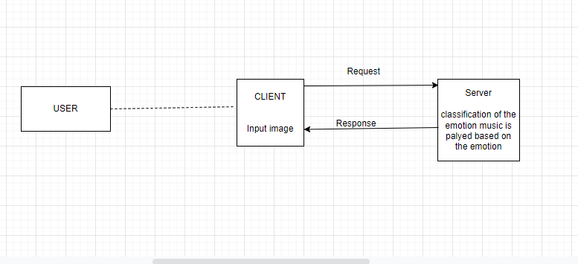

Fig 4. Client Server Model of FEB music recommendation system

## UML DESIGN

The Unified Modelling Language (UML) is a general-purpose, developmental, [modelling](https://en.wikipedia.org/wiki/Modeling_language) [language](https://en.wikipedia.org/wiki/Modeling_language) in the field of [software engineering](https://en.wikipedia.org/wiki/Software_engineering) that is intended to provide a standard way to visualize the design of a system. It is a standardized modelling language consisting of an integrated set of diagrams, developed to help system and software developers for specifying, visualizing, constructing, and documenting the artifacts of software systems. The creation of UML was originally motivated by the desire to standardize the disparate notational systems and approaches to software design.

The UML diagram is classified into two types:

* + Structural diagrams: It includes [class diagram,](https://creately.com/blog/diagrams/uml-diagram-types-examples/#ClassDiagram) [component diagram,](https://creately.com/blog/diagrams/uml-diagram-types-examples/#ClassDiagram) [deployment diagram,](https://creately.com/blog/diagrams/uml-diagram-types-examples/#DeploymentDiagram) [object diagram,](https://creately.com/blog/diagrams/uml-diagram-types-examples/#ObjectDiagram) [package diagram,](https://creately.com/blog/diagrams/uml-diagram-types-examples/#ObjectDiagram) [profile diagram,](https://creately.com/blog/diagrams/uml-diagram-types-examples/#ProfileDiagram) [composite structure](https://creately.com/blog/diagrams/uml-diagram-types-examples/#ProfileDiagram) [diagram.](https://creately.com/blog/diagrams/uml-diagram-types-examples/#CompStrDiagram)
  + Behavioural diagrams: It includes use case diagram, activity diagram, state machine diagram, sequence diagram, communication diagram, interaction overview diagram, timing diagram.

## ADVANCED CLASS DESIGN

In software engineering, a class diagram in the Unified Modelling Language (UML) is a type of static structure diagram that describes the structure of a system by showing the system's classes, their attributes, operations (or methods), and the relationships among the classes. It explains which class contains information

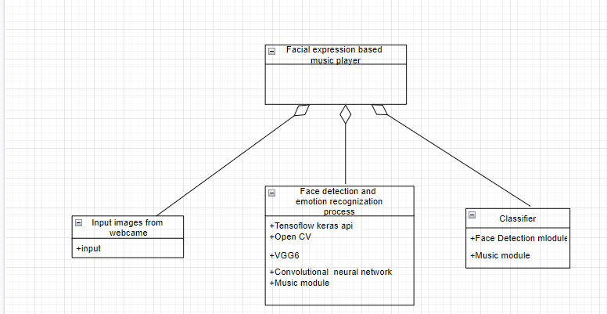

Fig. 5.1.1. Class Diagram of FEB music recommendation system

## ADVANCED STATE DESIGN

A state diagram is a graph whose nodes are states and whose directed arcs are transitions between states. It is used to represent the condition of the system or part of the system at finite instances of time. It’s a behavioural diagram and it represents the behaviour using finite state transitions. State diagrams are also referred to as State machines and State-chart Diagrams.

State names must be unique within the scope of state diagram. All objects in a class execute the state diagram for that class, which models their common behaviour. It provides a very detailed picture of how a specific symbol changes state.

## AGGREGATION CONCURRENCY

State aggregation means collection of state diagrams one for each part and relationship. Transition for one object depends on another object that allows interaction between the state diagram. The below figure shows the Facial expression based music player for Input images from webcam where face detection and emotion recognition process are done.

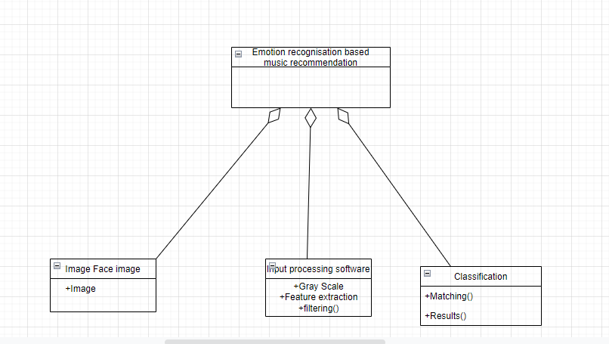

Fig. 5.1.2. Advanced Class Design of FEB music recommendation system

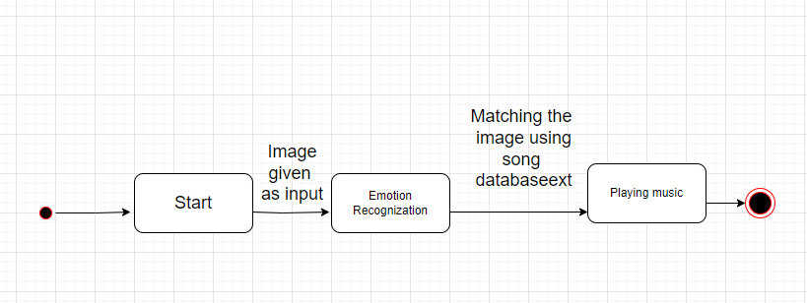

5.1.3. Advanced State Model of FEB music recommendation system

## ADVANCED INTERACTION MODEL

* + 1. USE CASE MODEL

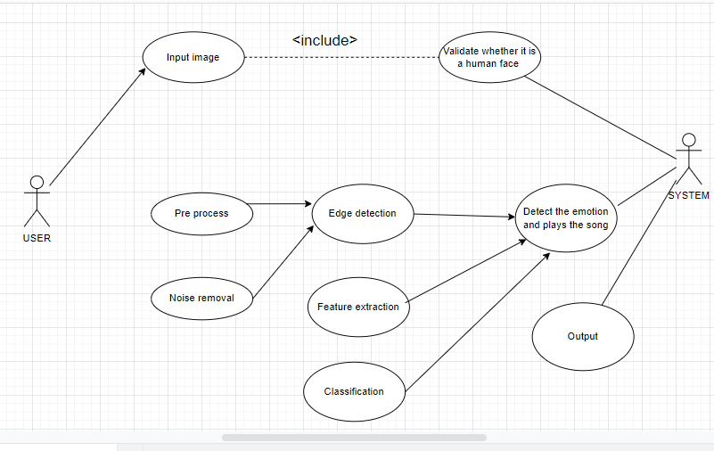

Fig 5.2.1. Use case Model of FEB music recommendation system

The following gives the description of use cases. 1.Use case: Input human face as input

User will give the human face as input to the model.

1. Actors: Users Include: Validation

Summary: System will validate whether given image is Human face or not. Actors: User

1. Use case: Classification

Summary: The System classifies the emotion Actors: System

1. Use case: Recognition

Summary: Recognize the emotion of the face. Actors: System

Generalization: Recognizing the expression of a face and playing the music according to the music.

* + 1. SEQUENCE MODEL

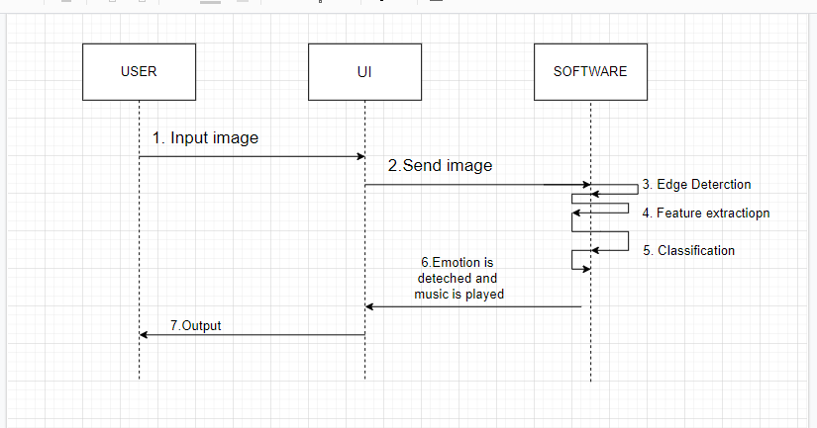

Fig. 5.2.2. Sequence model of FEB music recommendation system

Objects: User, UI, Software Messages:

1.Input Image 2.Send Image 3.Edge Detection 4.Feature Extraction 5.Classification

6.Emotion is detected and music played 7.Output

## SWIMLANE ACTIVITY MODEL

Swim lanes are used to show which activities are performed by priority/model in the swimlane activity diagram. A swimlane is a visual element used in process flow diagrams or flowcharts that visually distinguishes responsibilities for sub-processes of business process. Swimlanes may be arranged either horizontally or vertically. Lines across swimlane boundaries indicate interactions among different activities.

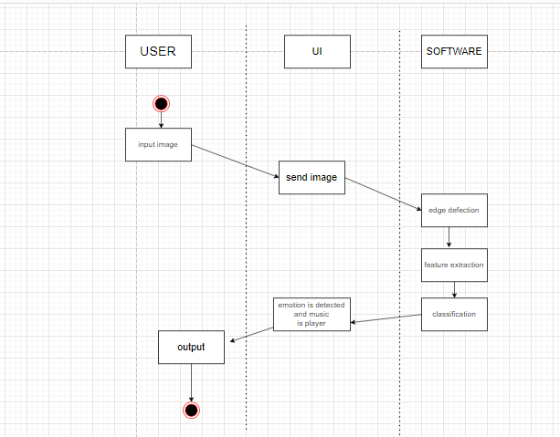

Fig 6. Swimlane Activity Model of FEB music recommendation system

Swimlanes: User, UI, Software

Initiation: User gives the image of human face as input through webcam.

**Activities:**

* + The image is inputted to the webcam.
  + The emotion of the user is being recognized by capturing the facial expression using OpenCV by identifying the Har features.
  + Feature Extraction will take place using VGG16.
  + The emotions are then classified into 7 different classes of emotions using a convolutional neural network (CNN).
  + Then the emotion is being sent to server and matched with Kaggel dataset.
  + The recognized expression is stored in database and the song which is related to that emotion is played from the music model.

**Termination:**

After the recognition of emotion in human face according to the emotion music is played as output and then the model enters to termination phase.

## USER DESIGN INTERFACE

User interface (UI) design is the process designers use to build interfaces in software or computerized devices, focusing on looks or style. Designers aim to create interfaces which users find easy to use and pleasurable. A Graphical User Interface is a user friendly interface between the user and system.

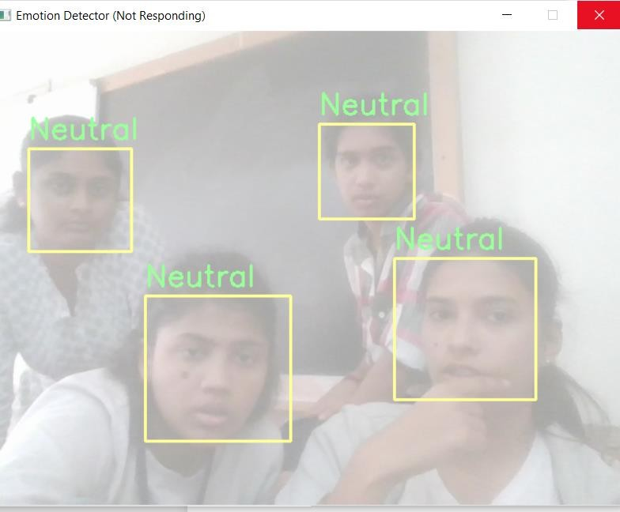

Fig 7. User Design Interface of FEB music recommendation system